

National College of Ireland

Project Submission Sheet

Student Name: | Bhavitha Thummunuru  ………………………………………………………………………………………………………………
Student ID: | 25211048  ………………………………………………………………………………………………………………
Programme: | Master of Science in Artificial Intelligence  ……………………………………………………………… | Year: | 2026  ………………………
Module: | Foundation of Artificial Intelligence  ………………………………………………………………………………………………………………
Lecturer: | Sallar Khan  ………………………………………………………………………………………………………………
Submission Due Date: | 19/05/2026  ………………………………………………………………………………………………………………
Project Title: | AI-Powered Logistics Optimization for EcoCart: A Technical Study of Search Algorithms, Machine Learning and Intelligent Agent Design  ………………………………………………………………………………………………………………
Word Count: | 1399  ………………………………………………………………………………………………………………

Academic Integrity Certificate Verification Code: …………………………………pYNE3HVh1M……………………………………

I hereby certify that the information contained in this (my submission) is information pertaining to research I conducted for this project. All information other than my own contribution will be fully referenced and listed in the relevant bibliography section at the rear of the project.
ALL internet material must be referenced in the references section. Students are encouraged to use the Harvard Referencing Standard or appropriate referencing style supplied by the Library. To use other author's written or electronic work is illegal (plagiarism) and may result in disciplinary action. Students may be required to undergo a viva (oral examination) if there is suspicion about the validity of their submitted work.

Note: Academic Integrity Course Requirement – Starting Monday, 19th January 2026, all students are required to successfully complete the Epigeum Academic Integrity Course, which is available on Moodle. This is a self-paced online course consisting of 4 modules and will take approximately 2 hours to complete. Once you have successfully completed the course, you will receive a Certificate & Verification Code. This code must be included on the Project Cover Sheet when submitting your work. For full details and guidance, please visit: 🔗 ttps://libguides.ncirl.ie/academicintegrity/epigeumforstudents

Signature: | ………………………………………………………………………………………………………………
Date: | ………………………………………………………………………………………………………………

PLEASE READ THE FOLLOWING INSTRUCTIONS:

1. Please attach a completed copy of this sheet to each project (including multiple copies).
2. Projects should be submitted to your Programme Coordinator.
3. You must ensure that you retain a HARD COPY of ALL projects, both for your own reference and in case a project is lost or mislaid. It is not sufficient to keep a copy on computer. Please do not bind projects or place in covers unless specifically requested.
4. You must ensure that all projects are submitted to your Programme Coordinator on or before the required submission date. Late submissions will incur penalties.
5. All projects must be submitted and passed in order to successfully complete the year. Any project/assignment not submitted will be marked as a fail.
6. Please check that you read AI and Academic Integrity Acknowledgement Supplments in this document

Office Use Only
Signature:
Date:
Penalty Applied (if applicable):

AI Acknowledgement Supplement

[Insert Module Name]

[Insert Title of your assignment]

Your Name/Student Number | Course | Date

This section is a supplement to the main assignment, to be used if AI was used in any capacity in the creation of your assignment; if you have queries about how to do this, please contact your lecturer. For an example of how to fill these sections out, please click here.

AI Acknowledgment
This section acknowledges the AI tools that were utilized in the process of completing this assignment.
Tool Name | Brief Description | Link to tool

Description of AI Usage
This section provides a more detailed description of how the AI tools were used in the assignment. It includes information about the prompts given to the AI tool, the responses received and how these responses were utilized or modified in the assignment. One table should be used for each tool used.
[Insert Tool Name]
[Insert Description of use]
[Insert Sample prompt] | [Insert Sample response]

Evidence of AI Usage
This section includes evidence of significant prompts and responses used or generated through the AI tool. It should provide a clear understanding of the extent to which the AI tool was used in the assignment. Evidence may be attached via screenshots or text.

Additional Evidence:
[Place evidence here]

Academic Integrity Acknowledgement Supplement

The red square below indicates certificate number, please put this in the above field



Academic Integrity Subject Guide or how to access the site: https://libguides.ncirl.ie/academicintegrity/epigeumforstudents
Completion of Epigeum Academic Integrity Online Course is Mandatory for
all registered students of NCI

Question 1
By leveraging data, AI can enhance the logistics operations of EcoCart and enable it to make informed decisions quickly and accurately. For this use case, AI can be leveraged for route optimization, inventory forecasting and customer segmentation. AI can be used for route optimization by analysing the locations of deliveries, the distances of the roads, the traffic situation, the capacity of the vehicles and their fuel consumption, to determine the most efficient delivery route. This not only shortens delivery timelines, but also lowers operational expenses and carbon emissions. AI can analyze past sales trends, seasonal demand, promotions and customer behavior to forecast future product demand for inventory forecasting. This enables EcoCart to keep a sufficient inventory without wastage. AI can also segment customers based on their buying patterns, geographical locations, order frequency and preferences, allowing marketers to target specific groups more effectively. An AI agent is a system that observes the environment around itself, processes information and makes decisions on it based on that information and acts accordingly to achieve a goal (Miller et al., 2025). For example, in the case of EcoCart, delivery data can be fed into a route optimisation agent, allowing it to choose the best delivery route. Use a goal-based agent since it is trying to achieve a specific objective, e.g., minimum distance or fastest delivery. A utility-based agent is also beneficial as it can reduce multiple criteria such as cost, time, fuel consumption and carbon emissions. A learning agent is appropriate for customer segmentation because it can get better at classifying the customers with additional customer data.

Question 2
It is possible that the customer segmentation algorithm may present skewed results for urban customers, due to the possible existence of more records representing urban customers in the training data than rural customers. The model may learn urban behaviour more strongly, as urban consumers might place more and/or higher-quality orders, have access to better internet, etc. and generate more digital transaction data. Rural customers can be underserved, leading the algorithm to incorrectly devalue them or not see them as being in a position to be marketed to. Other features, such as postcode, frequency of purchase, average order value, or browsing behaviour, can also cause bias, as these may be indirect measures of location and income differences.
EcoCart needs to compare the performance of each model with urban customers and rural customers to detect this bias. The following performance measures should be evaluated for each group: accuracy, precision, recall, conversion rate, false positive and false negative rates. If the model works a lot better for the urban folks, this is an indication of unfairness. EcoCart should normalize the data set by adding more rural customer data or employing sampling methods to prevent any biases. It should also eliminate or carefully manage characteristics that have a negative impact on rural customers. Fairness testing should be conducted prior to deployment and a fair test should be carried out throughout the use of the model (Chen et al., 2024). Human involvement can be an additional safeguard to prevent unfair exclusion of rural customers from marketing decisions.

Question 3

Search Algorithms for Route Optimization
A prototype of the route optimization was created using sample map data for EcoCart's delivery network. The Warehouse was used as the point of origin and the Customer as the final point of delivery. Intermediate nodes A, B, C, D, E, F and G were delivery points or road intersections and the values on the edges were travel cost, distance, or delivery time. The prototype was made to test DFS, BFS and A* and to determine which one of these algorithms would work best for efficiently calculating the shortest delivery path between several locations.
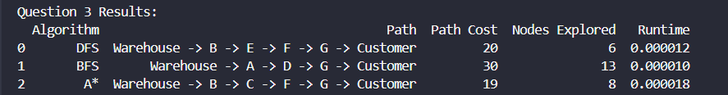
Figure 1: Console Output of Question 3 Code
The output of the prototype indicated that DFS explored 6 nodes and found the route Warehouse → B → E → F → G → Customer with a path cost of 20. BFS explored 13 nodes and found the shortest route: Warehouse → A → D → G → Customer, which has a path cost of 30. This A* found the shortest path costing 19 with the most nodes visited, random Warehouse, B, C, F, G, Customer.
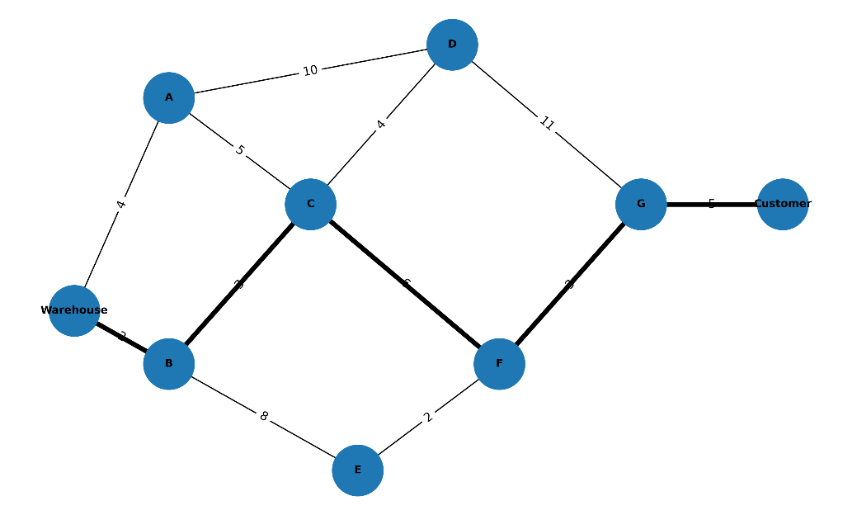
Figure 2: EcoCart Delivery Network and Best Route
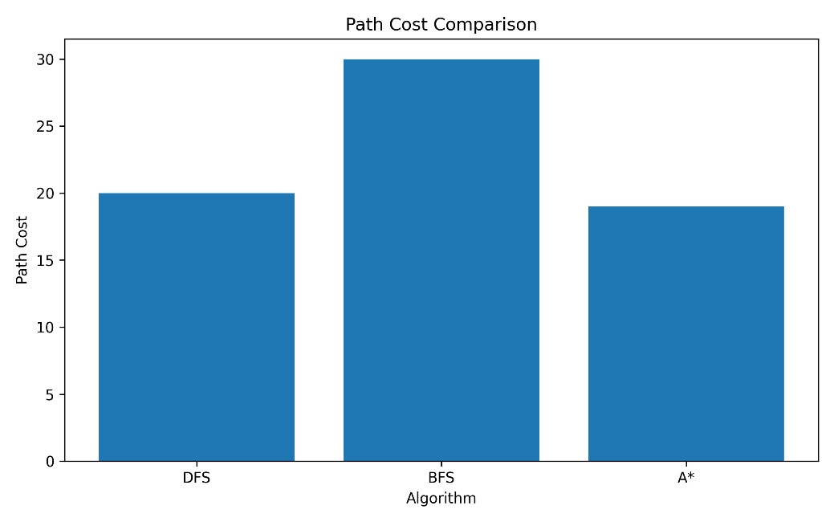
Figure 3: Path Cost Comparison Plot
From the results, it can be concluded that algorithm A* is the most suitable algorithm for this route optimization problem, as it explored the minimum number of nodes and also provided the shortest route, while DFS explored fewer nodes and also did not provide the shortest route, as it works on levels and not on weighted cost (Ismaeel and Zebari, 2025). A* was more effective as it factors in both path cost and heuristic distance, which is useful for the delivery route optimization task at hand with EcoCart.

Question 4

Question 4: Integrating A* and IDA* Algorithms
Two logistics route scenarios, urban delivery and rural delivery, were used for a comparative simulation, with A* and IDA* being tested on each. The urban route network was shorter and more connected and the rural route network had longer travel distances with fewer route options. The same starting point (Warehouse) and the same ending point (Customer) were used for both algorithms. The intent of this comparison was to study computational efficiency and scalability in terms of path cost, number of nodes explored and the time taken.
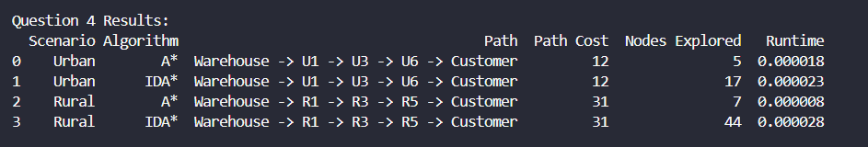
Figure 4: Console Output of Question 4 Code
The results indicated that the optimal route for both A* and IDA* was the same for each scenario. Both algorithms chose the same route for the urban route of Warehouse → U1 → U3 → U6 → Customer with a path cost of 12. However, A* could only find 5 nodes and IDA* could find 17 nodes. The Warehouse → R1 → R3 → R5 → Customer path cost for both algorithms is 31 on the rural route. Again, both algorithms found the same path cost, but A* explored just 7 nodes and IDA* explored 44 nodes.
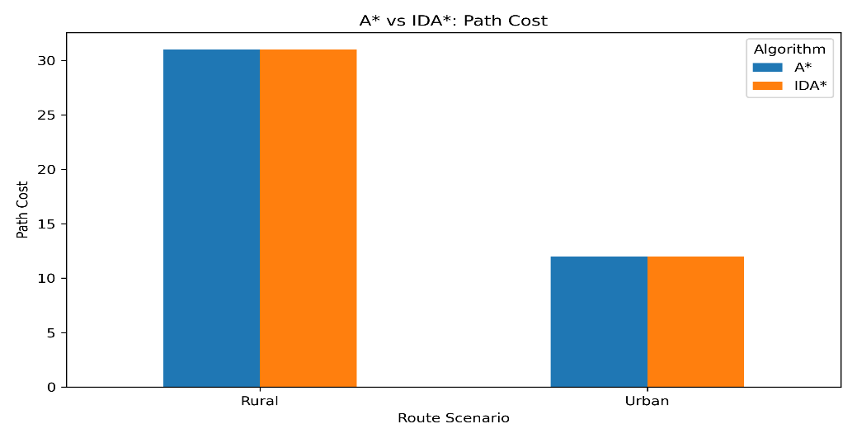
Figure 5: Path Cost Comparison Plot
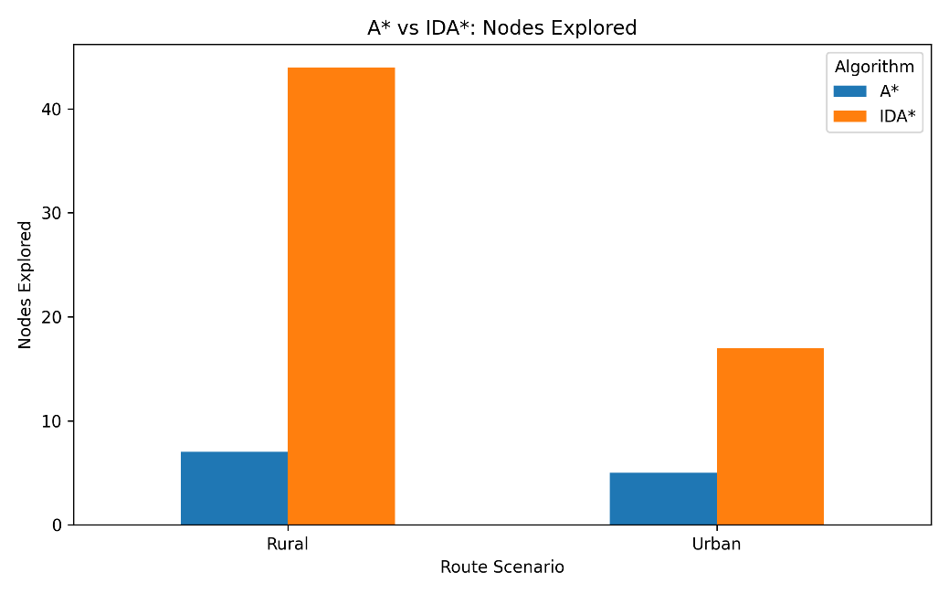
Figure 6: Comparison of Nodes Explored
By examining the path cost graph, both A* and IDA* had the same path cost for both urban and rural scenarios. The difference in efficiency of the computations is, however, evident in the nodes explored in the graph. IDA* did many more nodes, particularly in the rural route, as it repeated depth-limited searches, raising the depth limit each time. A* is more efficient since it stores explored paths and also uses the heuristic to guide the search more directly (Fransen and Van Eekelen, 2023). Even if speed and scalability are a requirement, IDA* can still be used if memory usage is required to be reduced, but in this prototype, A* showed better overall performance.

Question 5

Machine Learning Demand Forecasting
A sample historical sales data set was used to construct a machine learning model for predicting the demand of EcoCart's products. Some of the features in the dataset were month, product price, promotion, website visits and previous month sales. The dependent variable was the demand for the products, which was the expected number of sales of the products. To train the models on a subset of the dataset and evaluate them using data not seen during training, a split of the data into both training and testing sets was performed (Mohammed and Alsunosi, 2022). Implementation consisted of Linear Regression, Decision Tree Regressor and Random Forest Regressor.
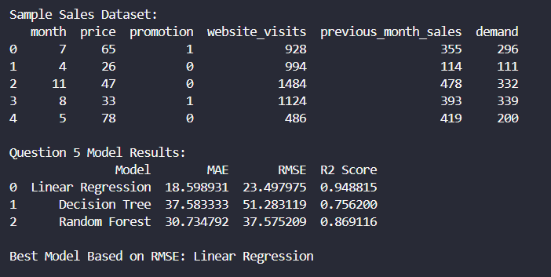
Figure 7: Console Output of Question 5 Code
Based on RMSE, the result indicated that Linear Regression was the best model. Linear Regression achieved an MAE of 18.598931, RMSE of 23.497975 and R² score of 0.948815. The RMSE value for Decision Tree is 51.283119 and for the Random Forest is 37.575209. As the lower RMSE value means the better prediction model, Linear Regression was chosen as the best model.
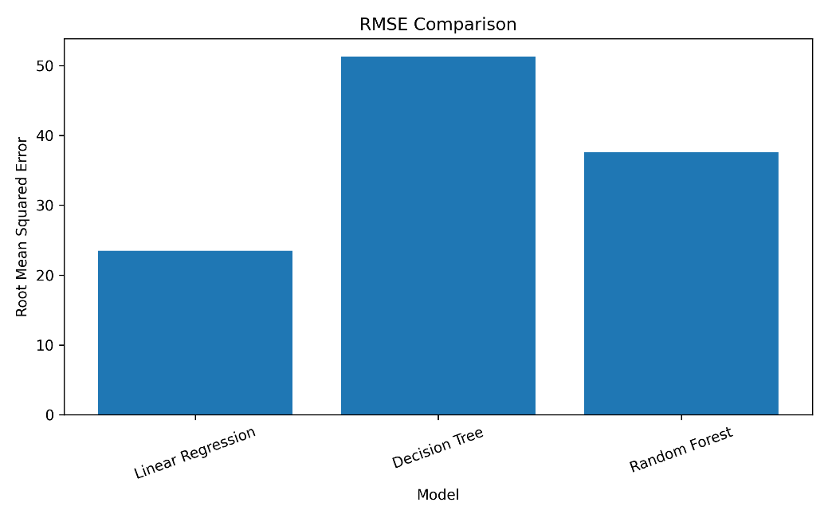
Figure 8: RMSE Comparison
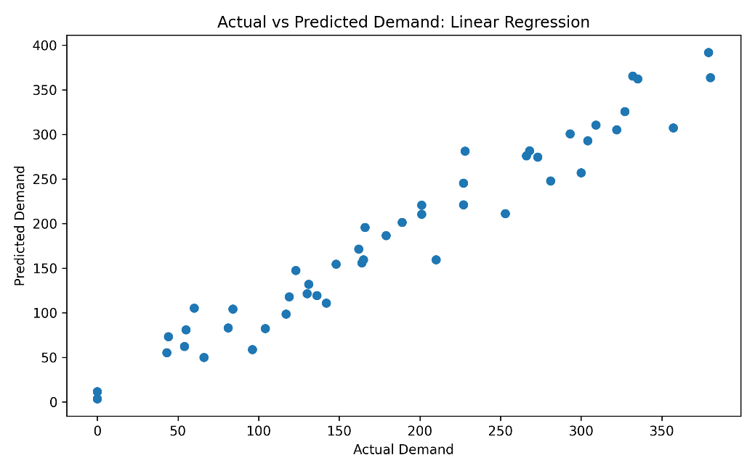
Figure 9: Actual vs Predicted Demand Plot
The comparison graph of RMSE indicates that Linear Regression model had the lowest prediction error than the other two models. The actual vs the predicted demand graph also demonstrates that the predicted values had followed the actual demand values closely as well. This means that the model learned the relation between demand and factors that mattered, like previous sales, visits to the web page, price and promotion. Hence, Linear Regression is appropriate for the task of forecasting the demand of EcoCart as it can give accurate predictions and is easy to explain to the business user.

References
Chen, Z., Zhang, J.M., Hort, M., Harman, M. and Sarro, F., 2024. Fairness testing: A comprehensive survey and analysis of trends. ACM Transactions on Software Engineering and Methodology, 33(5), pp.1-59. https://dl.acm.org/doi/pdf/10.1145/3652155?utm_source=consensus
Fransen, K. and Van Eekelen, J., 2023. Efficient path planning for automated guided vehicles using A*(Astar) algorithm incorporating turning costs in search heuristic. International journal of production research, 61(3), pp.707-725. https://www.tandfonline.com/doi/pdf/10.1080/00207543.2021.2015806
Ismaeel, A.Z. and Zebari, I.M., 2025. Comparing Traversal Strategies: Depth-first Search vs. Breadth-first Search in Complex Networks. Asian Journal of Research in Computer Science, 18(2), pp.60-73. https://www.researchgate.net/profile/Ibrahim-Mahmood-8/publication/394091462_Comparing_Traversal_Strategies_Depth_first_Search_vs_Breadth_first_Search_in_Complex_Networks/links/6889141d0786937984557a79/Comparing-Traversal-Strategies-Depth-first-Search-vs-Breadth-first-Search-in-Complex-Networks.pdf
Miller, T., Durlik, I., Kostecka, E., Kozlovska, P., Łobodzińska, A., Sokołowska, S. and Nowy, A., 2025. Integrating artificial intelligence agents with the internet of things for enhanced environmental monitoring: applications in water quality and climate data. Electronics, 14(4), p.696. https://www.mdpi.com/2079-9292/14/4/696
Mohammed, M. and Alsunosi, R., 2022. Effect of selecting validation dataset on building random forest and decision tree models. AlQalam Journal of Medical and Applied Sciences, pp.470-478. https://journal.utripoli.edu.ly/index.php/Alqalam/article/download/180/177

